**Pandora’s Labyrinth  
Jordan Akehurst  
ID: 21039327**

***Verbs***

**Player:**

* Move
* Collect
* Hide
* Shoot

**Enemy:**

* Hover
* Attack
* Move

**Minotaur:**

* Chase
* Attack

**Projectile:**

* Move
* Hit

***Players View***

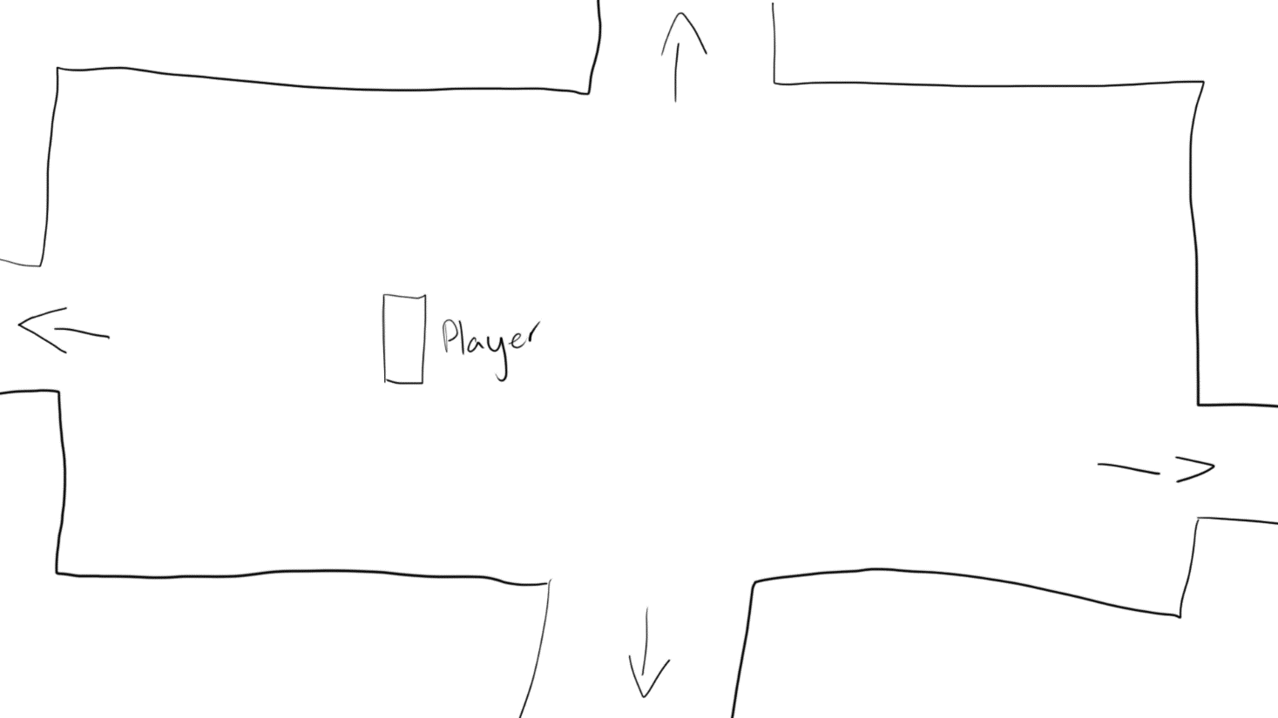

The Goal: Find pandora’s box and exit the labyrinth.

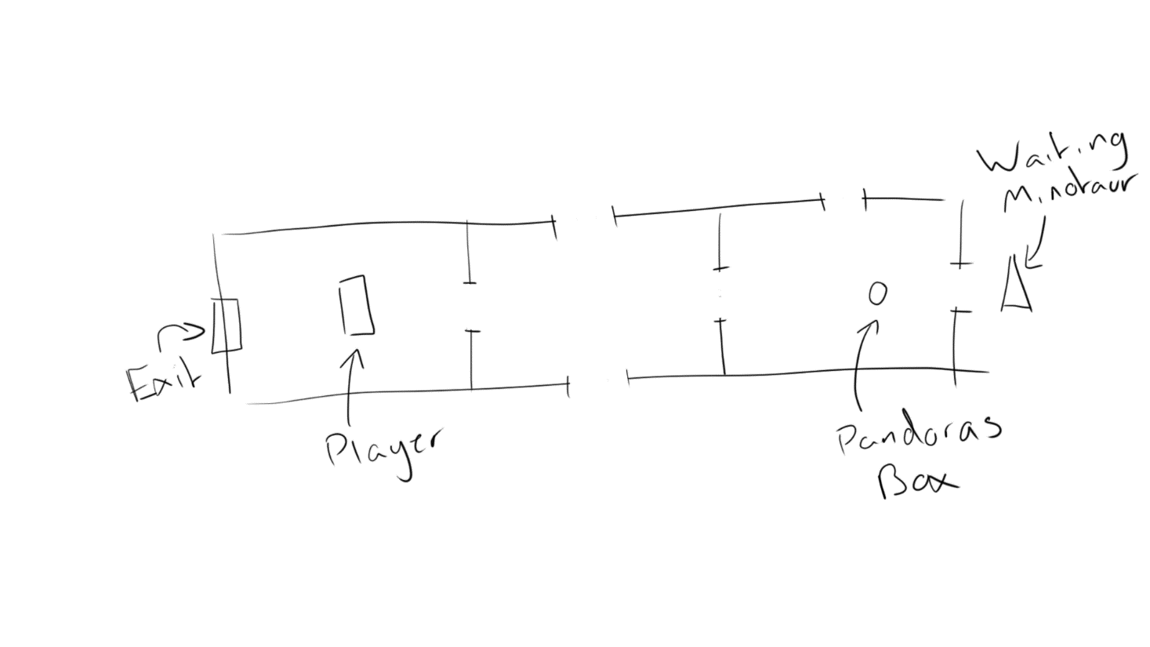

Pandora’s box can be found in only 1 which is always the furthest from the players spawn point. For you to reach pandora’s box, you will have to defeat enemies to unlock doors to the next rooms. But when you collect pandora’s box, the minotaur is released. The minotaur will chase you until caught, the only way to escape is to leave the labyrinth via the exit found in the starting room.

***Matrix                                                                   _***

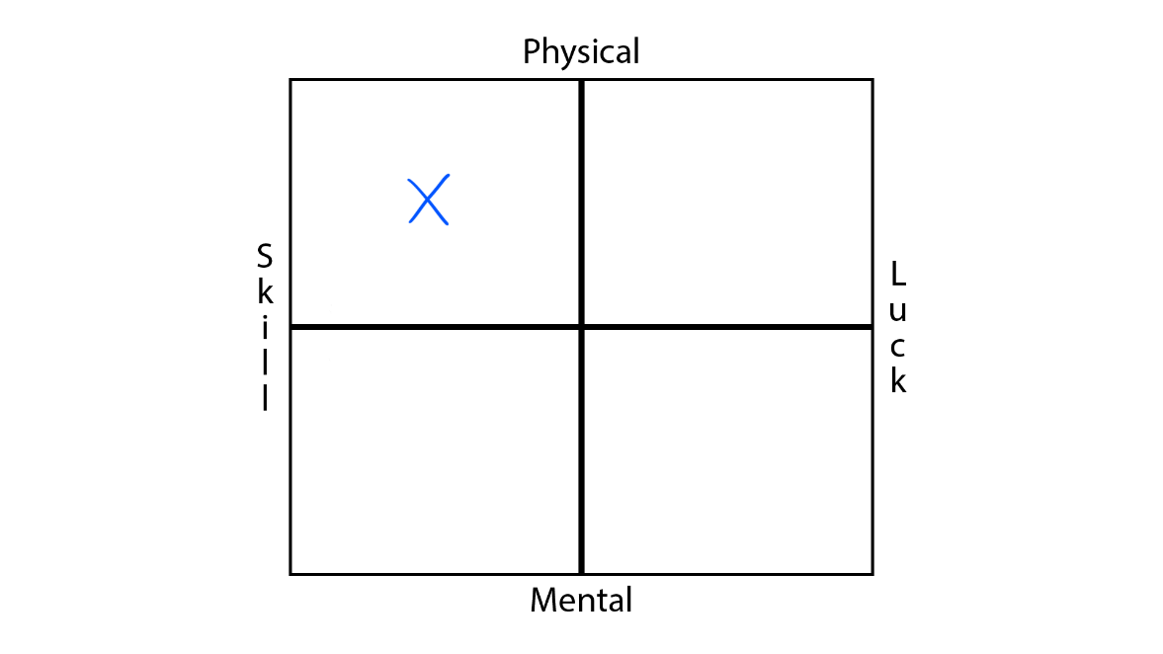

***The Experience of Play***

**Learning and Strategy:**

To win the game, the player must reach Pandora’s Box which is located on the opposite side of the level to the players spawning room. To get there the player must go through several rooms. Each room can contain different obstacles to overcome. One room type is combat, this room contains enemies for the player to fight in order to continue as the exits of this room are locked until all enemies are defeated.

***Gameplay Storyboards***

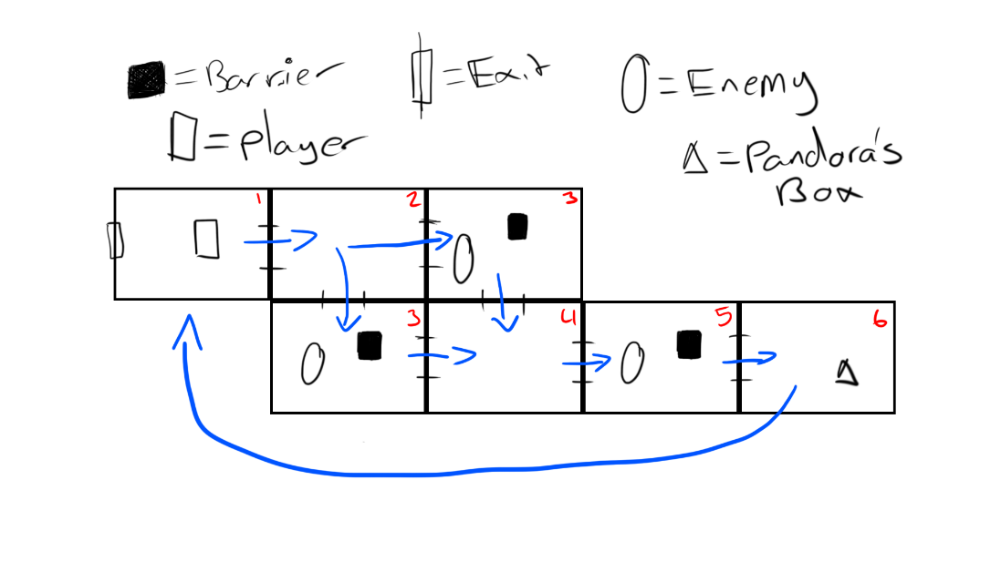

1. The player starts in the ‘spawn’ room. The exit is locked so the player moves to the next room.
2. This room is empty by default however it can contain obstacles including spike floors or a non-direct path.
3. The player is locked in a room with no exit, in order to move onto the next room the player must defeat all enemies in the room using the weapon the player starts with, a bow. When an enemy health reaches 0, they have a chance to drop a weapon upgrade for the player to equip. When all enemies are defeated, the doors are unlocked.

4/5) These are the same as 2 & 3 depending on the room type.

6) When the player enters the room, they will see Pandora’s Box. When they collect the item, the minotaur is released. The minotaur will chase the player, if caught the player dies and the game is over and the player loses. If the player reaches the exit found in the starting room before the minotaur catches them then the game is over and the player wins.

***Conditions***

**If** player intersects with exit && player hascollected = true

**Then** gamestate = **game over win**

**If** minotaur intersects with player

**Then** gamestate = **game over lose**

**If** player health <= 0

**Then** gamestate = **game over lose**

***Controls***

**If** gamestate = ingame

**If** player presses **A** or **Left Arrow** Key

**Then** player object moves left continuously.

**If** player presses **D** or **Right Arrow** Key

**Then** player object moves right continuously.

**If** player presses **W** or **Up Arrow** Key

**Then** player object moves up continuously.

**If** player presses **S** or **Down Arrow** Key

**Then** player object moves down continuously.

Player movement is **Vector** based, input sets x or y to -speed or speed.

Player movement is **Not** clamped by location.

***Events and Actions***

// Item Interaction

**If** player is colliding with weapon upgrade && presses **E** Key

**Then** upgrade is applied to the players weapon.

**If** player presses **E** key && is colliding with pandora’s box

**Then** pandora’s box is collected **and** minotaur is released

// Combat Interaction

**If** minotaur collides with player

**Then** gamestate = game over lose

**If** player hits the minotaur to ¾ or ½ health

**Then** minotaur movement speed is reduced.

**If** player is within hitbox of enemy && presses **Left Mouse Button**

**Then** player faces enemy (axis flip) and enemy health -= player damage.

**If** enemy attacks && is within hitbox of player

**Then** player health -= enemy damage.

**If** player shoots while projectile equipped

**Then** projectile is created and moves towards recorded mouse position

**If** projectile hits a wall type collision

**Then** projectile is destroyed

**If** projectile hits an enemy type collision

**Then** enemy health is reduced and projectile is destroyed

// Level Interaction

**If** room objective is completed

**Then** doors to adjacent rooms are unlocked, allow the player to enter

**If** objective timer > minimum timer

**Then** room difficulty is increased

***Object Models (Data)***

**// SYSTEM MANAGEMENT**

**Game Manager** GameManager.cs

Properties (Variables):

* **PUBLIC Vector3** currentRoom
* **PUBLIC String** gameState // PreGame, In-Game, EndGame
* **PUBLIC GameObject** player, currentRoomParent

**// ENTITY RELATED**

**Player** PlayerController.cs

Properties (Variables):

* **PUBLIC Float** speed
* **PUBLIC Vector3** velocity
* **PUBLIC Sprite** projectileSprite, projectColSprite
* **PUBLIC INT** projectileSpeed, fireRate, fireTimer
* **PRIVATE GameObject** projectile
* **PRIVATE Bool** toggleFireType, canFire

**Enemy** EnemyAI.cs

Properties (Variables):

* **PUBLIC Float** speed
* **PUBLIC Vector3** velocity
* **PUBLIC Sprite** projectileSprite, projectColSprite
* **PUBLIC INT** projectileSpeed, fireRate, fireTimer
* **PRIVATE GameObject** projectile
* **PRIVATE Bool** toggleFireType, canFire

**Minotaur** MinotaurAI.cs

Properties (Variables):

* **PUBLIC Float** speed
* **PUBLIC Vector3** velocity

**// PHYSICS CONTROLLERS**

**Player** CollisionManager.cs

Properties (Variables):

* **PUBLIC Bool** enableCollision
* **PUBLIC Enum** collisionType // Soft, Hard
* **PRIVATE collisionType** objectCollision
* **PRIVATE PlayerController** playerScript
* **PRIVATE GameObject** playerObject, projectileObject, enemyObject, minotaurObject
* **PRIVATE Sprite** playerSprite, thisSprite
* **PRIVATE Vector3** pushBack
* **PRIVATE Float** plBounds, prBounds, puBounds, pdBounds, playerSizeX, playerSizeY, enemyOffset
* **PRIVATE Float** elBounds, erBounds, euBounds, edBounds, enemySizeX, enemySizeY, enemyOffset
* **PRIVATE Float** mlBounds, mrBounds, muBounds, mdBounds, minotaurSizeX, minotaurSizeY, minotaurOffset

**Projectile** ProjectileManager.cs

Properties (Variables):

* **PUBLIC Vector3** mouseClick, velocity
* **PUBLIC INT** destroyTimer
* **PUBLIC Sprite** collideSprite
* **PRIVATE GameObject** colliderTest
* **PRIVATE SpriteRenderer** colliderSprite
* **PRIVATE Bool** hasCollided

**// MICRO-MECHANICS**

**Door Management** DoorController.cs

Properties (Variables):

* **PUBLIC GameObject** collisionBox
* **PUBLIC Float** animSpeed
* **PUBLIC Bool** isUnlocked, animFinished, forceUpdate
* **PRIVATE CollisionManager** boxCollision
* **PRIVATE Vector3** spawnPos, spawnScale
* **PRIVATE Color** thisColour
* **PRIVATE INT** animTimer

**Hide Objects (while in play)** HideOnPlay.cs

Properties (Variables):

* **PRIVATE Color** thisColour
* **PRIVATE SpriteRenderer** thisSprite

***Entity Relationships                                           _***

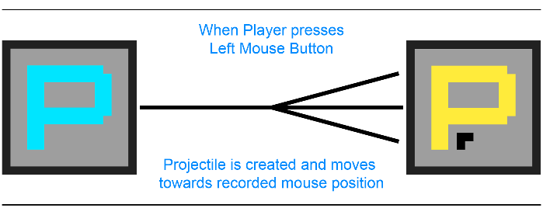

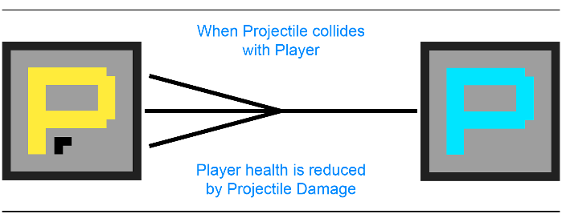 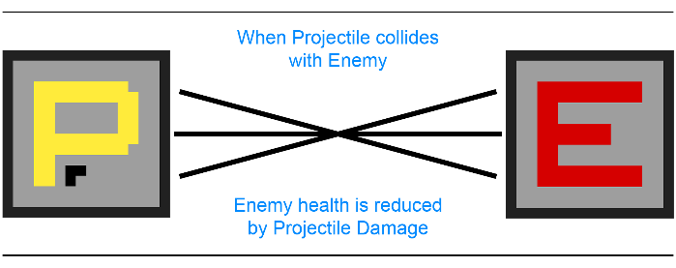

***Finite State Machines***

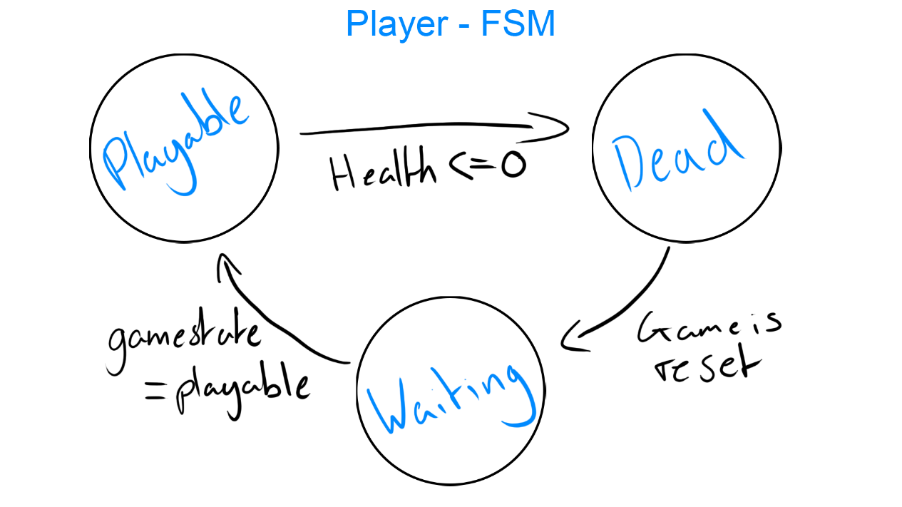

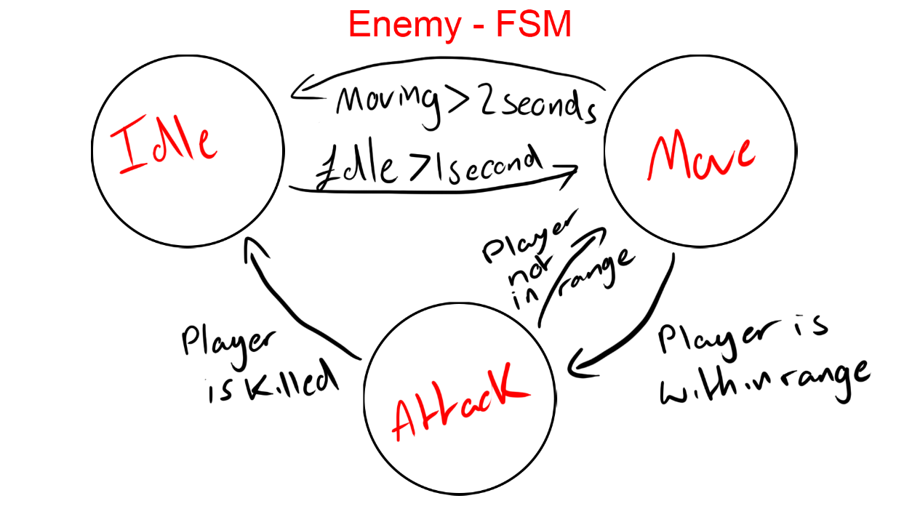

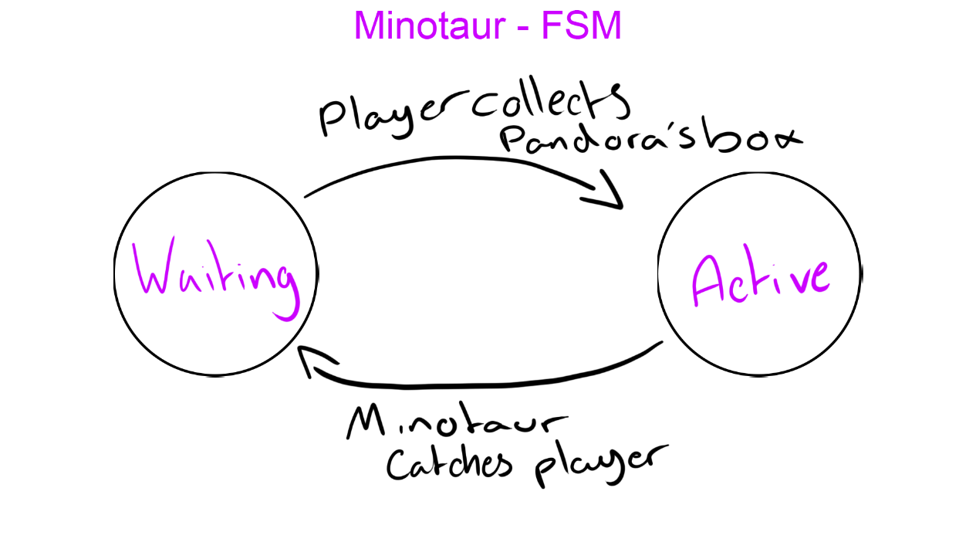

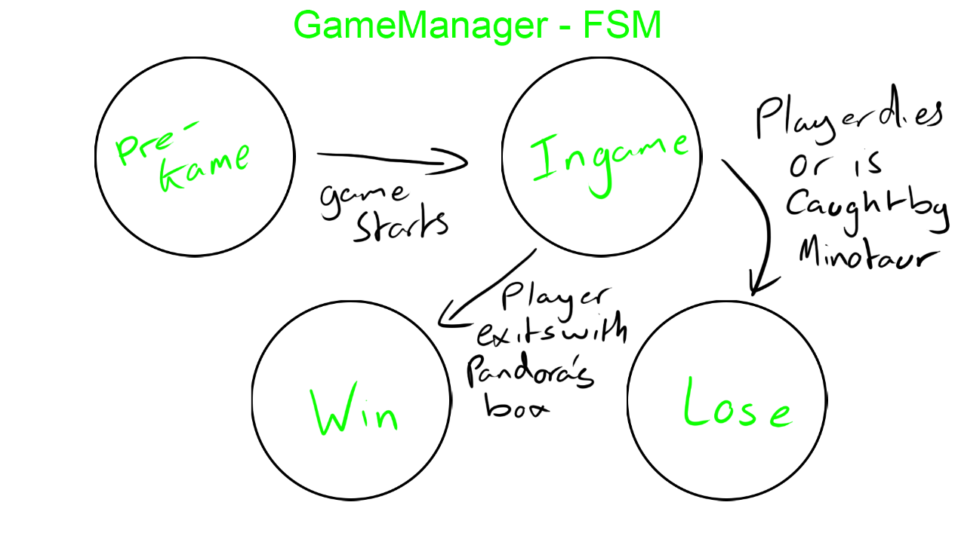

***Intermediate expansions of the basic version__***

* Added Puzzle rooms
* Multiple premade levels
* Minotaur randomly spawns in a room between the player and exit

***Advanced expansions of the basic version***

* Randomly generated level based on grid system
* High score leader board
* Added upgrade shop room

**LINK TO MY TRELLO BOARD:** <https://trello.com/b/dIPjgj01/jordan-akehurst>